**Name: Jatin**

**ID: 3157521**

**Title: Cargo Services**

**Task 1 - Identify the problem**

**Call Discussion with Client: Robin**

I am writing the matter call record with Robin. He is running business ‘Cargo Services’. he needs a software to maintain the records of his customers. He wants to maintain all the parts in his business where he is facing so many problems to maintain the record. he always wastes so much time to find the client details from copies and registers and sometimes he lost the records. so he has to face so many difficulties to maintain the record for future. So he needs an application for the record maintence where he can see on which date he has case in court and with which client.

**Task 2 - Define and document requirements**

Requirement of The Software

Scope of Work

*Features: I am going to create software of on Cargo Services. Which will be fully automated and robin can maintain and store the data for future. He can see all the customers and Bookings through this application online. This application would be fully secure. Data will be saved in the future efficiently. And no unauthorized person can make changes in it. So Application would be very effective and efficiency.*

*Functional Requirements: Demanded requirements by end user:-*

1. *He wants customer module save update and delete and list of customers to view.*
2. *Then he wants driver module in the software.*
3. *He wants vehicle type module in the software.*
4. *He wants the record of vehicles.*
5. *He wants login and logout facility in the software.*

*Non-functional requirements:*

1. System should be portable.
2. System should be reliable.
3. System should be secure.
4. Performance of system should be good.
5. System should be flexible.

Time: It will take minimum 20 days to complete.

The 4 essential steps of the Risk Management Process are:

1. Identify the risk.
2. Assess the risk.
3. Treat the risk.
4. Monitor and Report on the risk.

Cost: $350

Project management:- Project management is the science and art of organizing all the components of a project. For example, the launching of a new service, a marketing campaign, or the development of a new product are projects. In fact, even a wedding is a project that requires management.

**Task 3 - Design mockups**

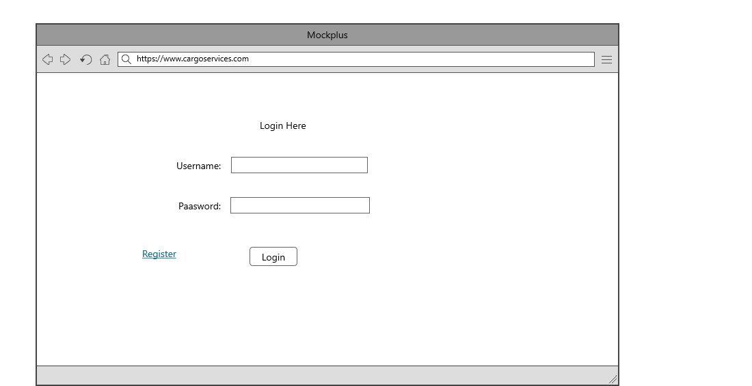

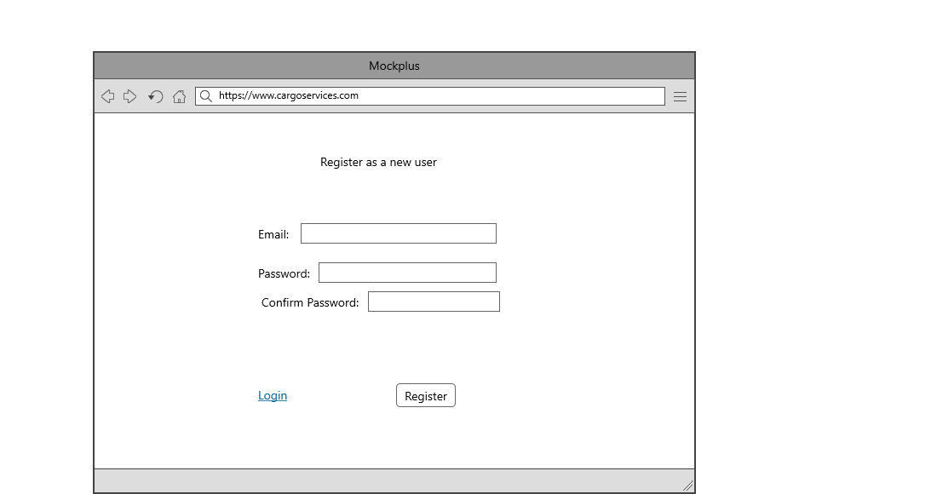

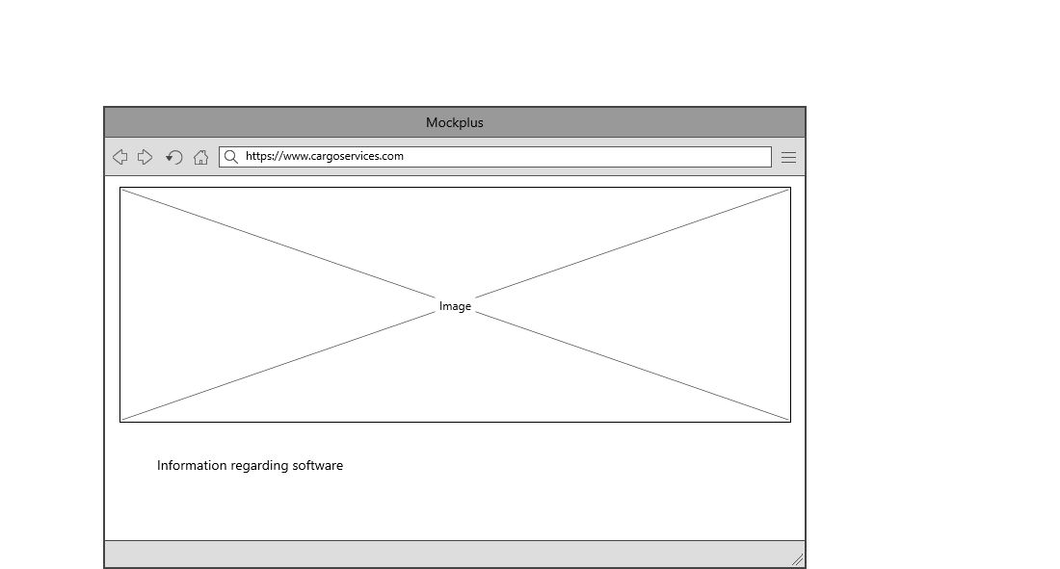

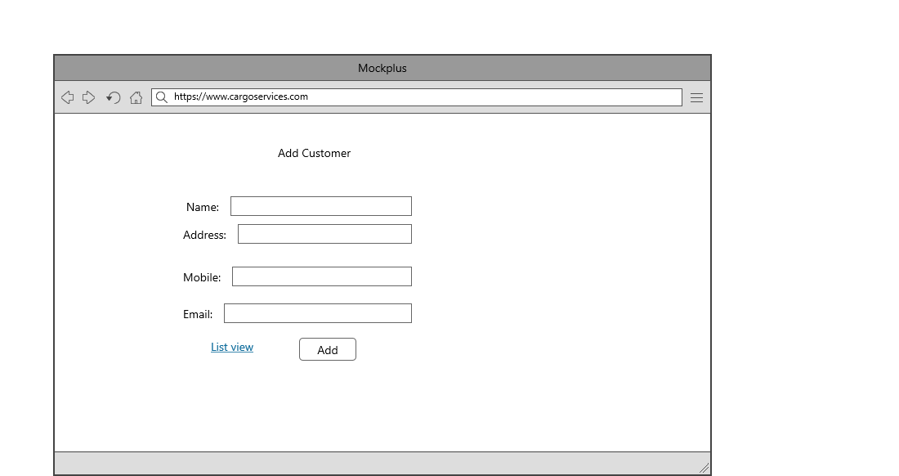

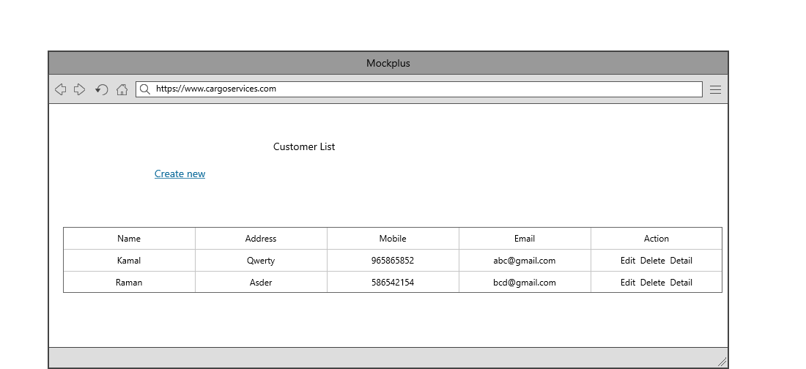

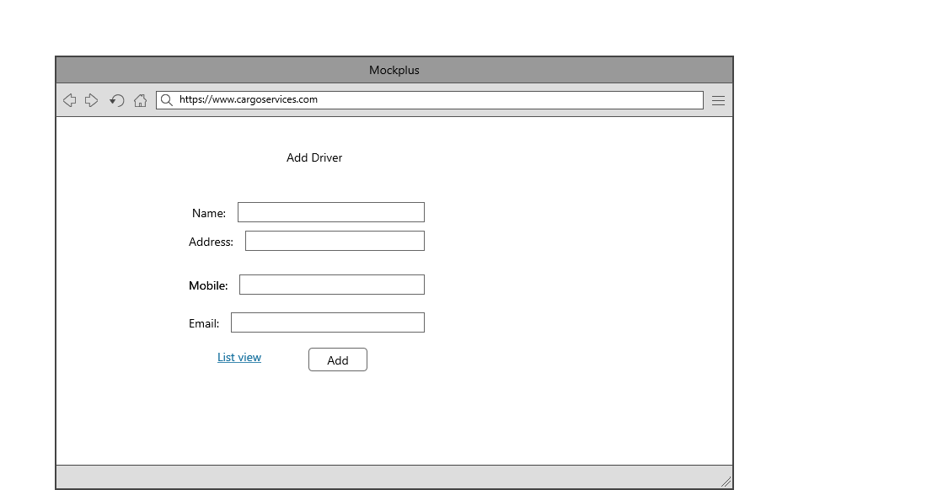

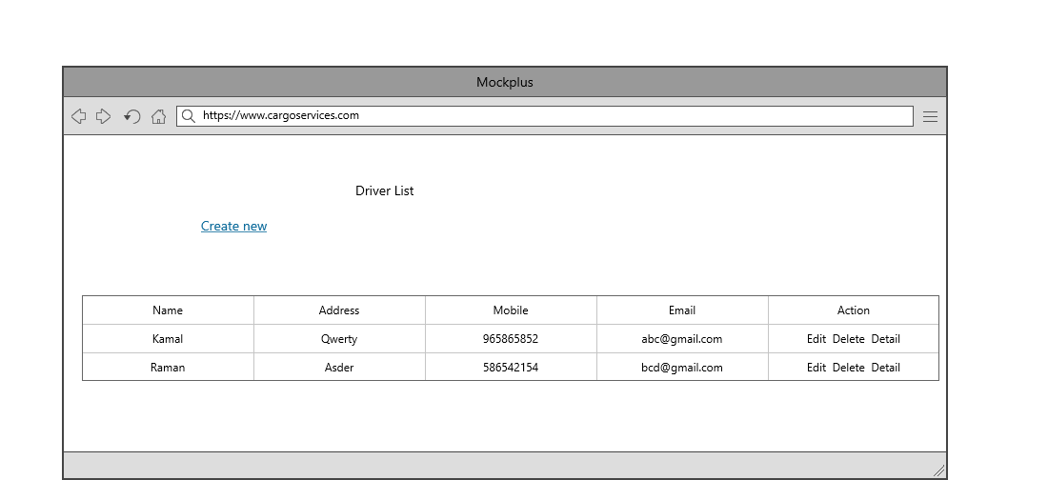

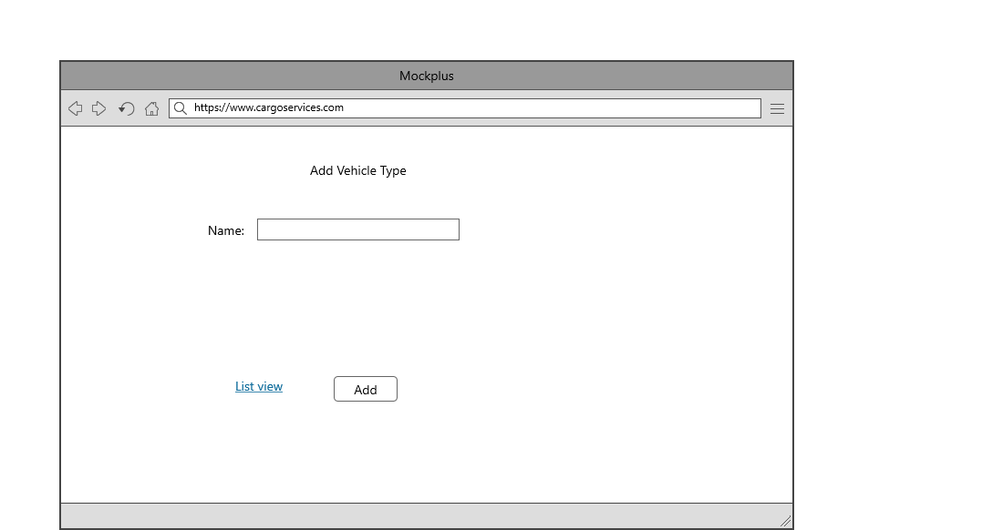

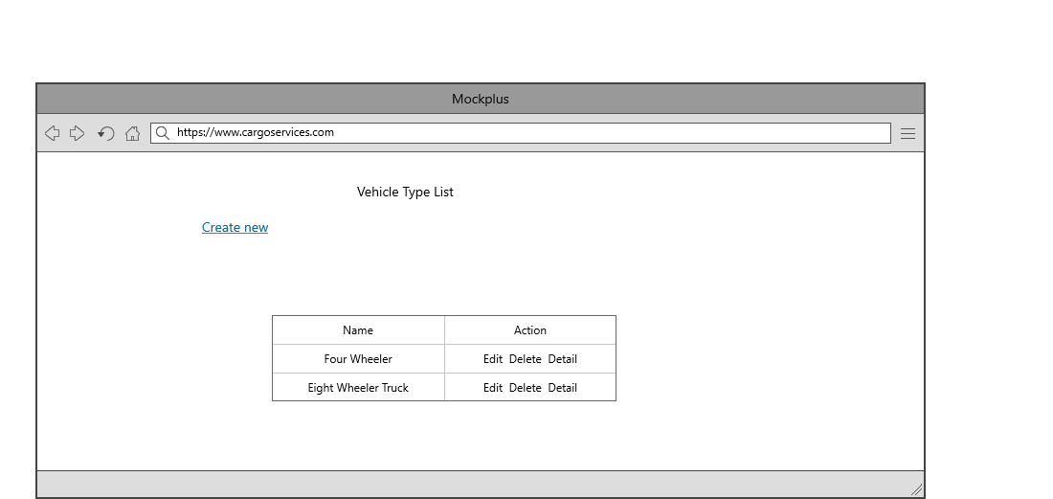

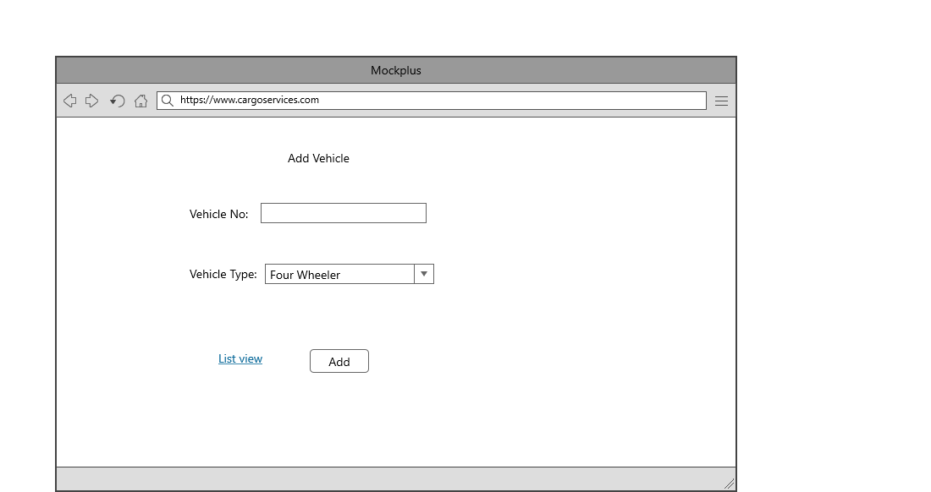

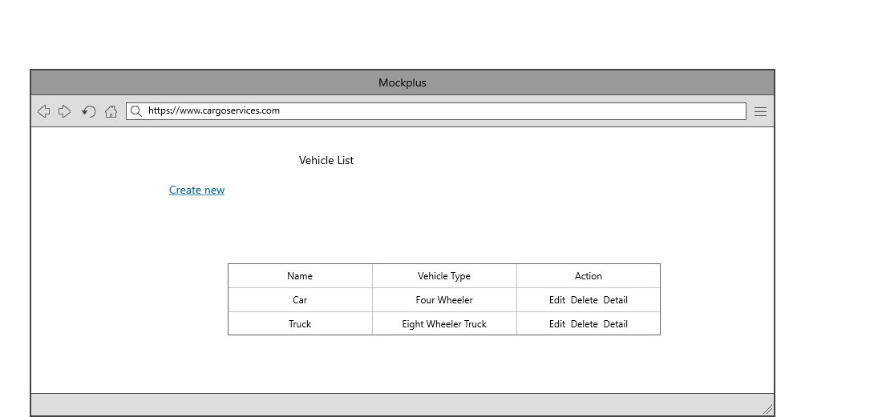

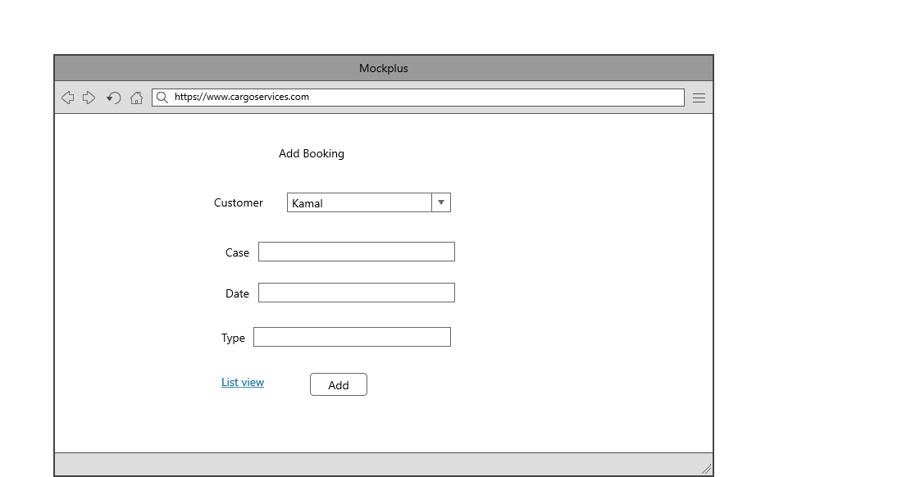

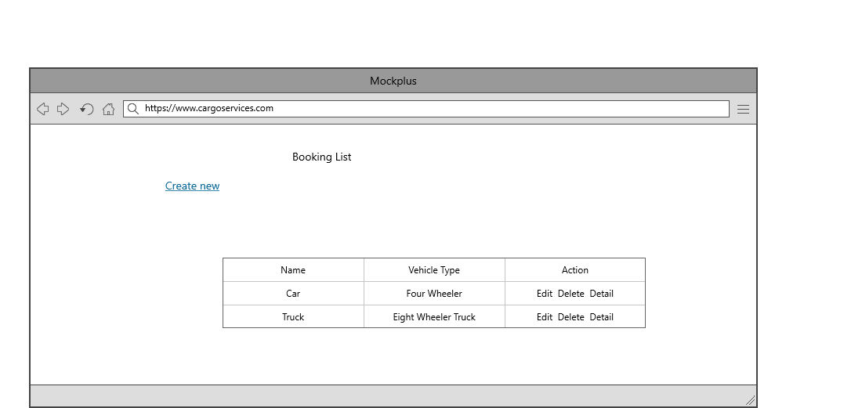

## Task 5- usability testing

|  |  |  |  |  |  |
| --- | --- | --- | --- | --- | --- |
| **User #** | **Login form** | **Customer form** | **Booking Module** | **Pass / Fail / Not executed / Suspended** | **Reviews** |
| Robin | Looking pretty | Very Nice | As Expected perfect | Pass | All modules are ok |
| Manjit | Nice | Role based is good | Very Attractive | Pass | all modules are as expected |
| Sawan | might be more attractive | Very Good | should some changes and expand more | Pass | Login form should be more attractive |
| Sharan | Its ok | Ok | Perfect | Pass | Perfect Software |

**Task 6 - Meet with your client**

Client Meeting:

|  |
| --- |
| Meeting Details |
| * Date and time: 25-Oct-2021 * Location: Newzealand |
| Attendees: Jatin and Robin |
| Agenda: Discussion of Software of Cargo services |
| Discussion (Important Points): He needs customer and booking module on the highest priority. Left requirement is written on above. |
| My To Dos (Actions): Firstly I have to make the mockups of the application. Then Starting the application after the next meeting. |
| Questions requiring Follow- Up: Discussion of the mock ups |
| Comments: Robin is good person and he described regarding software very wisely. |
| Next meeting  Date and Time: 1- Nov-2021 1:00 Pm  Location: Newzealand  Agenda: Showing the mock ups to the client and discussion about further development. |

**Appendix 3**

**Client Review Form**

My developer’s name: Jatin

This form is intended to let you review the communication skills of your developer for this assignment. Your review will partly count towards their final mark. Do not take into account technical skills.

# Grading scale

You must grade your developer for each item listed in the tables below. 1 being the lowest, 5 the highest.

|  |  |  |  |  |
| --- | --- | --- | --- | --- |
| **1** | **2** | **3** | **4** | **5** |
| Strongly disagree | Disagree | Ok | Agree | Strongly agree |

# Review your developer

|  |  |  |
| --- | --- | --- |
| **Item** | **Grade** | **Comment** |
| Communicated clearly and effectively | 2 |  |
| Kept you informed of the progress | 5 |  |
| Met timelines | 4 |  |
| Responded promptly to problems | 3 |  |
| Met overall project objectives | 1 |  |
| Was open to new ideas and suggestions | 5 |  |
| Was easy to work with | 5 |  |

Comments

Provide any extra comments on your developer’s communication skills and professionalism.

Jatin is good developer. He is very good in his work. I proud to get my work completed by jatin.

## Signed by Client

|  |  |
| --- | --- |
| **Signature: Robin** | **Date: 13-nov-2021** |
| **Name: Robin** | **Title:Cargo Services Software** |
| **Contact details (email/Tel):** | |

**Task 8 - Software development life cycle stages**

**Planning :-** The project management plan should:

1. Define project schedule
2. Identify the resource requirement and allocated resources
3. Define Breakdown of tasks and their dependencies
4. Include cost estimation and project budget plan
5. Provide cost and schedule performance measurement
6. Schedule Milestones and reviews
7. Include an acquisition plan to define how the needed resources will be obtained and when

**Requirement :-** In order for Requirements Analysis to begin, there must be an approved Project Charter. The scope of the project will be understood and stated in the Project Charter. The roles and responsibilities for the various activities in the Development Life cycle will be known.

**Software Design and prototyping :-**

System design documents reflect a systems architecture, the structure of the components of a program or system, their interrelationships and the principles and guidelines governing their design and evolution over time. Relationships are both run-time and non run-time and hence architecture is also expressed in terms of components and connectors. A system architecture is not only a product of requirements but equally a result of organizational goals, the architect’s experience and her technical environment.

**1. Register Page: -** This is Register page in where you can register new user

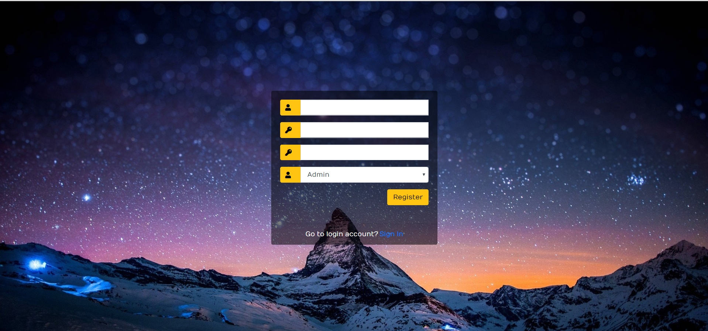

**2. Login Page: -** This is Login page of our website. In this page I can login as a Admin or as a Manager.

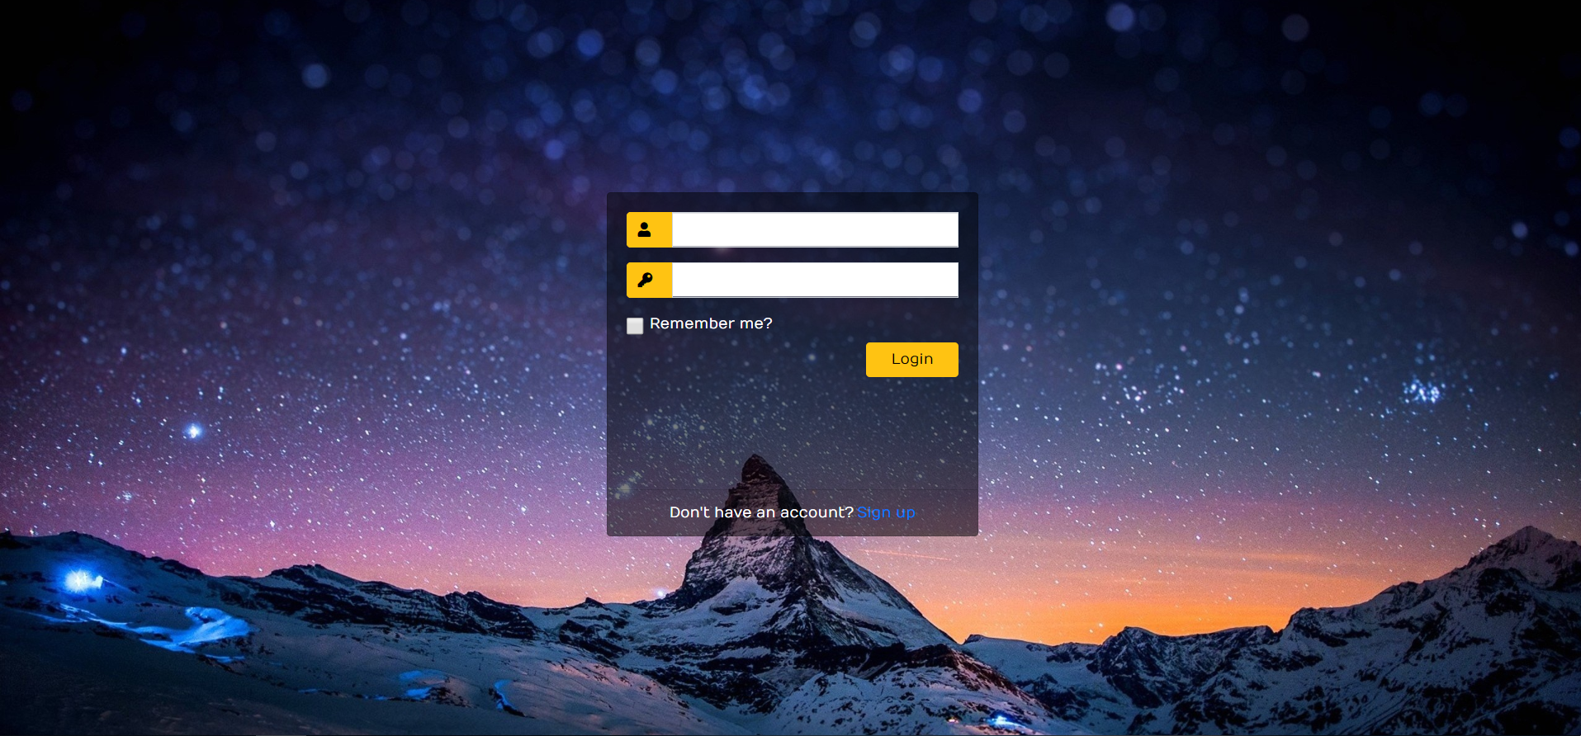

**3. Admin Login**: When admin logins then he can access the all modules of website. Which are shown in the picture.

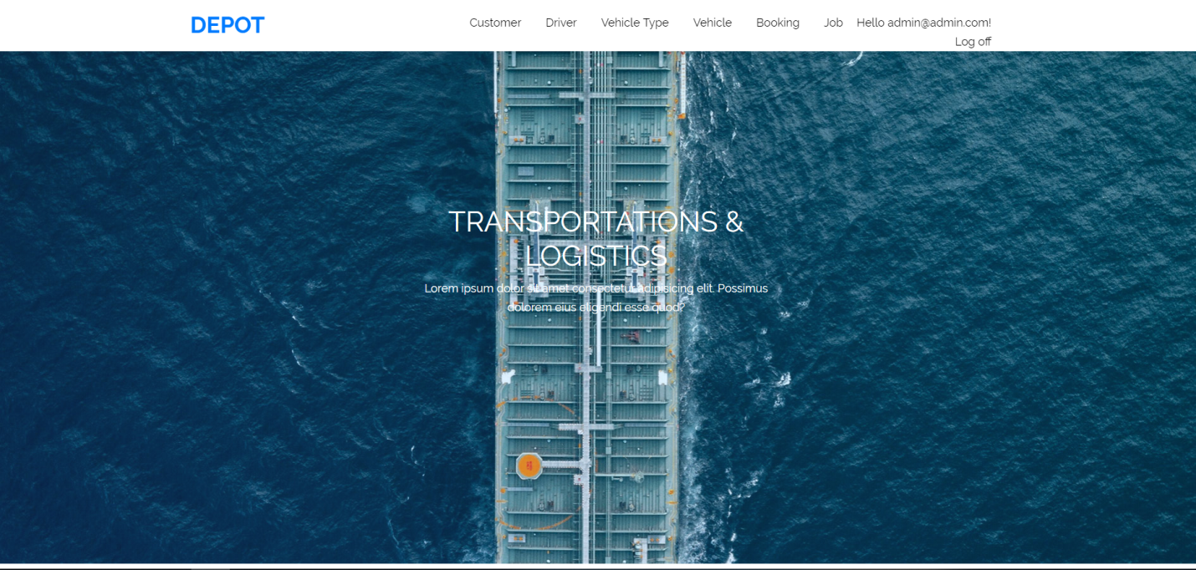

**4. Customer: -**  Here I can show the customer in my website. And clicking on the create new link I can create the customer. Edit and delete customer are also available here.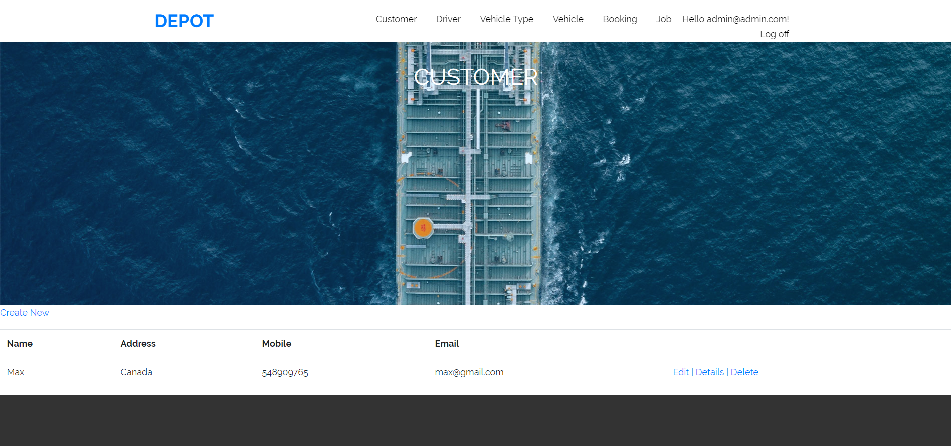

**5. Driver: -**  Here I can show the driver in my website. And clicking on the create new link I can create the driver. Edit and delete driver are also available here.

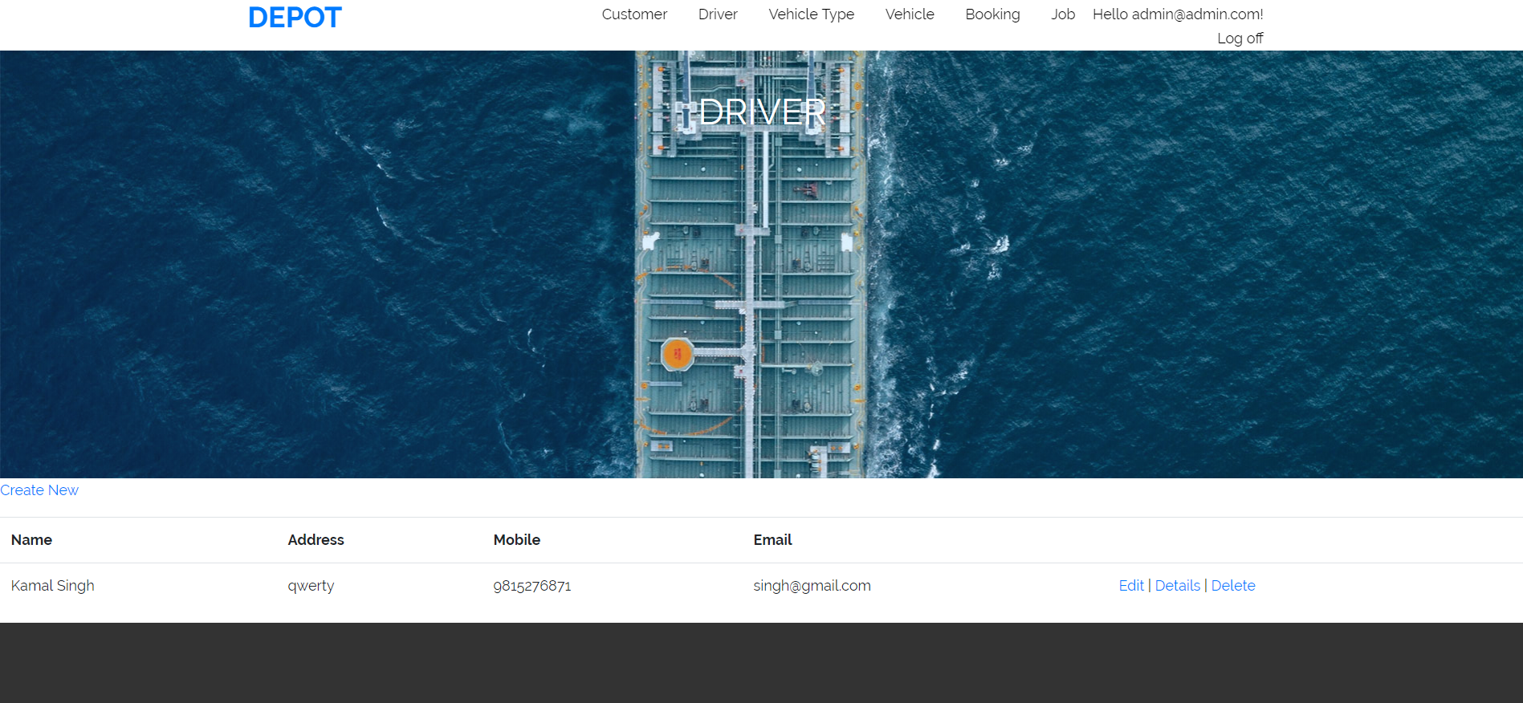

**6. Vehicle Type: -**  Here I can show the vehicle type in my website. And clicking on the create new link I can create the vehicle type. Edit and delete vehicle type are also available here.

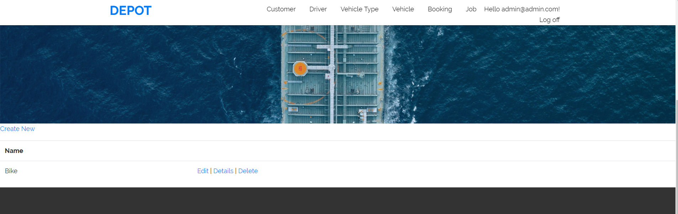

**7. Vehicle: -**  Here I can show the vehicle in my website. And clicking on the create new link I can create the vehicle. Edit and delete vehicle are also available here.

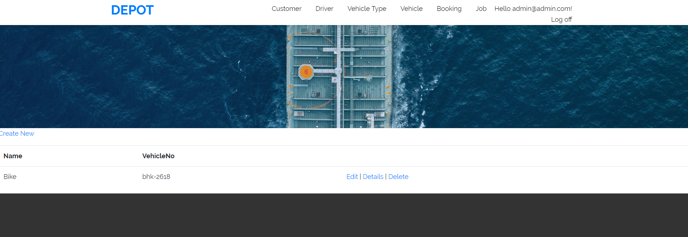

**8. Booking: -**  Here I can show the booking in my website. And clicking on the create new link I can create the booking. Edit and delete booking are also available here.

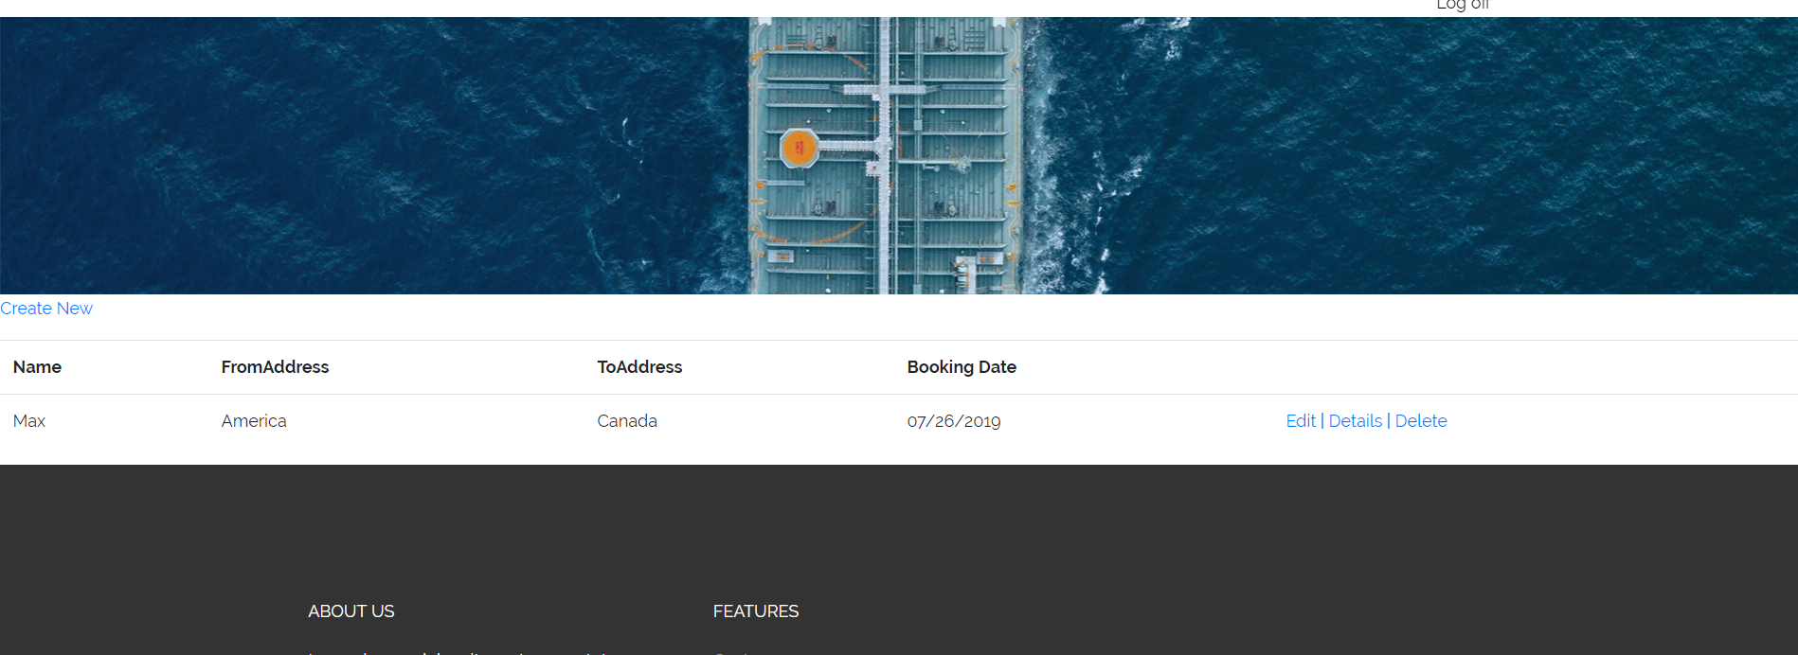

**Software Development:** We know we are ready to commence the software construction work if:

1. Technical specifications (SDD) are available.
2. Architecture is proven and signed off by the stakeholders.
3. Unit testing components ( test requirements, scripts, results, time-lines, cases, reports) are completed in the Master Test Plan Document.

**Testing:** The objective of this phase is to perform system integration testing of the developed system. The systems integration test function is to ensure that the developed systems meet all the technical requirements with the components and subsystems integrated. The system test may require any number of additional tests depending on the scope and complexity of the requirements; examples include: security, conformance, accessibility, performance, stress, compatibility, and regression tests.

**Task 9- Project management**

The starting point in discussing how projects should be properly managed is to first understand what a project is and, just as importantly, what it is not.

People have been undertaking projects since the earliest days of organized human activity. The hunting parties of our prehistoric ancestors were projects, for example; they were temporary undertakings directed at the goal of obtaining meat for the community. Large complex projects have also been with us for a long time. The pyramids and the Great Wall of China were in their day of roughly the same dimensions as the Apollo project to send men to the moon. We use the term “project” frequently in our daily conversations. A husband, for example may tell his wife, “My main project for this weekend is to straighten out the garage.” Going hunting, building pyramids, and fixing faucets all share certain features that make them projects.

A project has distinctive attributes that distinguish it from ongoing work or business operations. Projects are temporary in nature. They are not an everyday business process and have definitive start dates and end dates. This characteristic is important because a large part of the project effort is dedicated to ensuring that the project is completed at the appointed time. To do this, schedules are created showing when tasks should begin and end. Projects can last minutes, hours, days, weeks, months, or years.

So I have learnt many things from this project. I never think a lot of knowledge with project work I cab get in software. Now I can get job in IT easily.